Literature Review File: -Aritcles
This document separated into sections based on when the articles where first read read
Template provides the outline used for each entry
I’m using Zetero for reference management

To Do
- Combine articles from the repo, make entries
- Determine what program to use to generate and keep references - BibTex
- Make a separate reference file for easy bibliography later
- Draft – Friday (~3pages)
- Maybe rate the quality and how relevant each article is

Title: Analysis of electric load forecasting using combined method (Study case 2019 – 2029 in PT. PLN (Persero) UP3 Sukabumi) | Year: 2021  ISSN: 1757-8981  Zetero: Added  Saved: No
Abstract
Abstract The purpose of this study is to find out how much electric load to Sukabumi from 2019 until 2029 at PT. PLN (Persero) UP3 Sukabumi. Forecasting of electrical load using historical data. This research uses a combined method, which is a method compiled by combining several models such as econometrics, analysis, and trends with a sectoral approach, which is an approach by grouping electricity consumers into four sectors, namely the resident, commercial, public, and industrial sectors. The population forecast of Sukabumi in 2019-2029 shows an average growth of 0.36% per year. Gross Regional Domestic Product (GRDP) for resident sector growth of 6.26% per year, commercial sector growth of 6.26% per year, public sector growth of 6.26% per year, and the industrial sector growth of 10.07% per year. The electric customers for the resident sector growth of 5.26%, commercial sector growth of 13.96% per year, public sector growth of 7.58% per year, and industrial sector growth of 3.53% per year. The electric contracted power for the resident sector growth of 5.19% per year, commercial sector growth of 14.96% per year, public sector growth of 7.28% per year, and industrial sector growth of 3.36% per year. Growth of population, GRDP, number of electric customers, and power contracted, as shown in forecasting 2019-2029, will affect to increasing electrical load. The total electrical load will be 1,054.22 MVA in 2019 and 2,043.80 MVA in 2029 or growth of 6.74% per year.
Notes:
- grouping electricity consumers into four sectors, namely the resident, commercial, public, and industrial sectors
- electric load forecasting has applications in power system operations and planning, revenue management, energy trading ect.
- Separated forecasting into long, medium and short term
  - Long term: yearly variation (main impact: year to year variability)
  - Medium: monthly (main impact: seasonality of month)
  - Short term: day-hour (main impact: intraday cycle and intraweek cycle)
Title:  Short-Term load Forecasting 2019 | Year: 2021  ISBN: 3-03943-442-X  Zetero: Added  Saved:Yes
Abstract
Short-term load forecasting (STLF) plays a key role in the formulation of economic, reliable, and secure operating strategies (planning, scheduling, maintenance, and control processes, among others) for a power system and will be significant in the future. However, there is still much to do in these research areas. The deployment of enabling technologies (e.g., smart meters) has made high-granularity data available for many customer segments and to approach many issues, for instance, to make forecasting tasks feasible at several demand aggregation levels. The first challenge is the improvement of STLF models and their performance at new aggregation levels. Moreover, the mix of renewables in the power system, and the necessity to include more flexibility through demand response initiatives have introduced greater uncertainties, which means new challenges for STLF in a more dynamic power system in the 2030–50 horizon. Many techniques have been proposed and applied for STLF, including traditional statistical models and AI techniques. Besides, distribution planning needs, as well as grid modernization, have initiated the development of hierarchical load forecasting. Analogously, the need to face new sources of uncertainty in the power system is giving more importance to probabilistic load forecasting. This Special Issue deals with both fundamental research and practical application research on STLF methodologies to face the challenges of a more distributed and customer-centered power system.
Notes
- Introduced term “active customers” for those who participate in electricity markets (energy, capacity, or balance)
- The usefulness and relevance of hybrid or combined models, together with multistep methodologies, is indisputable.
- Article 6 uses a novel model combining a data pre-processing technique, forecasting algorithms, and an advanced optimization algorithm; [6]
- The last 2 papers are a good example of using the classical methods
- Two review papers of this book represent an advance on this topic: [9], which discusses four categories of state-of-the-art STLF methodologies (similar pattern, variable selection, hierarchical forecasting, and weather station selection), where each of these methods proposes a specific solution for load prediction.
- The author emphasizes the need for creating additional and case-specific performance criteria for electricity load forecasting (better accuracy does not imply lower costs caused by forecasting errors)
- There are many features we must consider developing a good STLF (short term load forecasting) model, such as climatic factors, seasonality, and calendar effects. Article 13 also highlights the importance of distinguishing different types of special days
- Article 15 uses a forecasting method based on convolution neural networks combined with data augmentation technique that can artificially enlarge the training data.
- Article 16-17 cover the issue cause by a lack of historical data or limited data

Title: (Book)  Forecasting and Assessing Risk of Individual electricity peaks | Year: 2020  ISBN: 3-030-28668-1  Zetero:Yes  Saved:no
Abstract
The overarching aim of this open access book is to present self-contained theory and algorithms for investigation and prediction of electric demand peaks. A cross-section of popular demand forecasting algorithms from statistics, machine learning and mathematics is presented, followed by extreme value theory techniques with examples.In order to achieve carbon targets, good forecasts of peaks are essential. For instance, shifting demand or charging battery depends on correct demand predictions in time. Majority of forecasting algorithms historically were focused on average load prediction. In order to model the peaks, methods from extreme value theory are applied. This allows us to study extremes without making any assumption on the central parts of demand distribution and to predict beyond the range of available data. While applied on individual loads, the techniques described in this book can be extended naturally to substations, or to commercial settings. Extreme value theory techniques presented can be also used across other disciplines, for example for predicting heavy rainfalls, wind speed, solar radiation and extreme weather events. The book is intended for students, academics, engineers and professionals that are interested in short term load prediction, energy data analytics, battery control, demand side response and data science in general.
Notes
- Current modelling is based on point values (averages) so it is no surprise that these types of forecasts have been the dominant tool in the past. However, market competition and requirements to integrate renewable technology have inspired interest in probabilistic load forecasts (PLF) particularly for system planning and operations. PLF may use quantiles, intervals and/or density functions [10]
- Linear regression model – created hourly load forecasts, considered temperature (squared), day number and the interaction between the two. They refined the model using smoothed temperature readings from different weather stations, removing outliers and considering national holidays (eg:Christmas) as different from regular holidays. –pg 19
- New keyword search term Probabilistic load forecasts

Title:  Short term electric power load forecasting using factor analysis and long short-term memory for smart cities | Year: 2020  ISSN: 0098-9886  EISSN: 1097-007X  zetero: yes  Saved: No
Abstract
Electric load estimation is an important activity for electrical power system operators to operate the system stably and optimally. This paper develops a machine learning model with a long short‐term memory and a factor analysis to predict the load at a specific hour of the day on an electrical power substation. Historical load data from the 33‐/11‐kV substation near Kakatiya University in Warangal are taken at each hour of the day for the period from September 2018 to November 2018. A new long short‐term memory architecture with factor analysis is being designed based on the approach used to predict substation loads by simulation in Microsoft Azure Notebooks. Based on the study, it was found that the proposed design predicts loads with good accuracy. The versions of the LSTM, i.e., LSTM‐HAM‐Model1 and LSTM‐DAM‐Model1, have been designed to forecast loads with reasonable precision relative to current simple neural networks so that utilities can trade energy efficiently. The lightweight models, e.g., LSTM‐HAM‐Model2 and LSTMDAM‐Model2, were developed by reducing input features using factor analysis. These lightweight models predict the load with almost same precision as the initial models. In the smart cities, the proposed models will help power utilities trade electricity efficiently.
Notes
- Long short term-memory and a factor analysis
- Short-term load forecasting with good accuracy is a challenging task, but it is helpful for a secure and stable powersystem operation. As per the statistical analysis, there is even a 1% increase in prediction accuracy leads to considerableprofit. High-speed and good accuracy short-term load forecasting is required for economical load dispatch in power sys-tems. As a result, an efficient short-term electric power load prediction model is very important and useful for smartgrid operations and also improves decision making
- ANN, SVMs, regression models, Rfs and decision trees are used to solve STLF
- Lit review:
  - hybrid approach based on decision tree and expert system was developed in Salgado and Lemes [11]
  - Yang,12it was proposed to predict the hourly load data using Fourier seriesforecast model with the least squares.
  - Ke et al.13to predict active power load basedon auto encoder and gated recurrent unit (GRU). Auto encoder is used to compress input features, and GRU is used topredict loads.
  - Multiple linear regression model predicting load hourly
- The paper goes over how they designed a LSTM model

Title:  Short-Term Load Forecasting of Electricity Demand for the Residential Sector Based on Modelling Techniques: A Systematic Review | Year: 2023  ISSN: 1996-1073  zetero: yes  Saved: No
Abstract
In this paper, a systematic literature review is presented, through a survey of the main digital databases, regarding modelling methods for Short-Term Load Forecasting (STLF) for hourly electricity demand for residential electricity and to realize the performance evolution and impact of Artificial Intelligence (AI) in STLF. With these specific objectives, a conceptual framework on the subject was developed, along with a systematic review of the literature based on scientific publications with high impact and a bibliometric study directed towards the scientific production of AI and STLF. The review of research articles over a 10-year period, which took place between 2012 and 2022, used the Preferred Reporting Items for Systematic and Meta-Analyses (PRISMA) method. This research resulted in more than 300 articles, available in four databases: Web of Science, IEEE Xplore, Scopus, and Science Direct. The research was organized around three central themes, which were defined through the following keywords: STLF, Electricity, and Residential, along with their corresponding synonyms. In total, 334 research articles were analyzed, and the year of publication, journal, author, geography by continent and country, and the area of application were identified. Of the 335 documents found in the initial research and after applying the inclusion/exclusion criteria, which allowed delimiting the subject addressed in the topics of interest for analysis, 38 (thirty-eight) documents were in English (26 journal articles and 12 conference papers). The results point to a diversity of modelling techniques and associated algorithms. The corresponding performance was measured with different metrics and, therefore, cannot be compared directly. Hence, it is desirable to have a unified dataset, together with a set of benchmarks with well-defined metrics for a clear comparison of all the modelling techniques and the corresponding algorithms.
Notes
- circumstances indicate the essential need for an effective electric load forecasting system to accommodate several uncertainties associated with changing end-user-related load consumption behavior and RES intermittency [ 6,8 ,10 ]
- An accurate load forecasting system can reduce the high cost of excessive contracts and subcontracts in balance markets due to load forecasting errors
- STLF is often used to improve system operations and provide reliable service
- Energy demand forecasting techniques grouped into 3 categories
  - Correlation – relate system load demand curves to economic and demographic factors
  - Extrapolation – trend curves based on historical data on electricity demand
  - Combination of above 2
- no single method (machine learning technique) is scientifically accepted as being better than the others in all situations
- Part 4)
  - Increasing effort past 2 years into work on individual residence forecasting
  - Generally load profile in residential sector follows cyclical and seasonal pattern
  - In papers covered in lit review proposed dataset had a range of at least 2 weeks to a max of 10years
  - Warn that additional data that does not reinforce the accuracy of forecasting model can create noise, reduce performance and requires more computational time (variable selection)
  - To improve performance, added variables such as sociodemographic factors, energy prices, occupancy behavior and home appliances.
Title:  Artificial intelligence in short term electric load forecasting: a state of the art survey for the researcher | Year: 2002  ISSN: 0196-8904  zetero: yes  Saved: No
Abstract
Intelligent solutions, based on artificial intelligence (AI) technologies, to solve complicated practical problems in various sectors are becoming more and more widespread nowadays. AI-based systems are being developed and deployed worldwide in myriad applications, mainly because of their symbolic reasoning, flexibility and explanation capabilities. This paper provides an overview for the researcher of AI technologies, as well as their current use in the field of short term electric load forecasting (STELF). The history of AI in STELF is outlined, leading to a discussion of the various approaches as well as the current research directions. The paper concludes by sharing thoughts and estimations on AI future prospects in this area. This review reveals that although still regarded as a novel methodology, AI technologies are shown to have matured to the point of offering real practical benefits in many of their applications.
Notes
- The short term load forecast is required for unit commitment, energy transfer scheduling and load dispatch. With the emergence of load management strategies, the short term forecast is playing a broader role in utility operations. The development of an accurate, fast and robust short term load forecasting methodology is of importance to both the electric utility and its customers, thus introducing higher accuracy requirements.
- traditionally, STELF techniques use conventional smoothing techniques, regression methods and statistical analysis.
- Identifies Expert systems (Ess) and ANNs used in STELF (short term electric load forecasting) & then later on genetic algorithms
- Go over the important of load forecasting to the energy sector:
  - Electric utilities want to maximize long and short term operation system performance given the operating and economic characteristics of the generating units, the transmission line constraints and the limited amount of capital available for new units and equipment.
  - In general its important for companies and/or government bodies in the energy sector (specifically the electric sector) to have estimates of the short and long time variation, including load pattern changes of the electricity demand.
  - LF integral part of planning and operating an electric utility, forecasting helps system operator to schedule spinning reserve allocation efficiently. It’s also useful for power system security
- Efficient forecasting technique should include the principals
  - Causality
  - Reproducibility
  - Functionality
  - Sensitivity
  - Simplicity

- The short term load forecast is required for unit commitment, energy transfer scheduling and load dispatch. With the emergence of load management strategies, the short term forecast is playing a broader role in utility operations. The development of an accurate, fast and robust short term load forecasting methodology is of importance to both the electric utility and its customers, thus introducing higher accuracy requirements.
- Traditionally, STELF techniques use conventional smoothing techniques, regression methods and statistical analysis (such as peak load models and load shape models)
  - Load shape models rely on time series analysis
  - The autoregressive moving average model is among the most popular of the dynamic load shape models

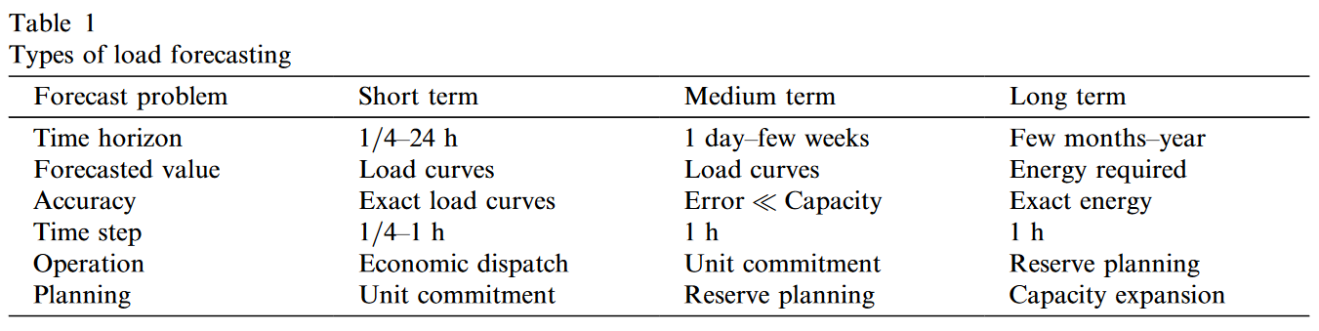
- In 1992, Peng et al. [40] presented a search procedure for selecting the training cases for ANNs to recognize the relationship between weather changes and load shape
- Electricity short term load forecasting is important for the power industry, especially in the deregulated electricity market. Proper demand forecasts help the market participants to maximize their profits and/or reduce their possible losses by preparing an appropriate bidding strategy.

Title:  Short-term electric power load forecasting using feedforward neural networks | Year:2004  ISSN: 0266-4720  zetero:yes  saved:
Abstract
This paper presents the results of a study on short‐term electric power load forecasting based on feedforward neural networks. The study investigates the design components that are critical in power load forecasting, which include the selection of the inputs and outputs from the data, the formation of the training and the testing sets, and the performance of the neural network models trained to forecast power load for the next hour and the next day. The experiments are used to identify the combination of the most significant parameters that can be used to form the inputs of the neural networks in order to reduce the prediction error. The prediction error is also reduced by predicting the difference between the power load of the next hour (day) and that of the present hour (day). This is a promising alternative to the commonly used approach of predicting the actual power load. The potential of the proposed method is revealed by its comparison with two existing approaches that utilize neural networks for electric power load forecasting.
Notes

Title:  Short-term electric load forecasting in Tunisia using artificial neural networks | Year:2019  ISSN: 1868-3967  zetero:yes  saved:
Abstract
The accuracy of short-term electricity load forecasting is of great interest since it allows avoiding unexpected blackouts and lowering operating costs. In this paper, we aim to implement the artificial neural networks to model and forecast the half-hourly electric load demand in Tunisia over the period 2000–2008. To improve the quality of forecasts, the proposed artificial neural network model uses not only past electric load values as inputs, but also climatic and calendar variables. To determine the optimal structure of the neural network model, this paper employs the pattern search algorithm. Moreover, the neural network model is equipped with the Levenberg–Marquardt learning algorithm. Our findings confirm the performance of this algorithm to the view of evaluation indicators since the mean absolute percentage error values range between 1.1 and 3.4%. The analysis also shows the superiority of the Levenberg–Marquardt algorithm compared to the resilient back propagation algorithm and the conjugate gradient algorithm. In the light of the current research, we stress the aptness of the proposed artificial neural network model in forecasting short-term electricity demand.
Notes
- Used past electric load, climate and calendar variables
- Use levenberg-marquardt learning algorithm (over back propagation)
- Applied pattern search optimization algorithm to determine the number of hidden layers and the number of neurons in each layer
- Below table of variables they used in the model:

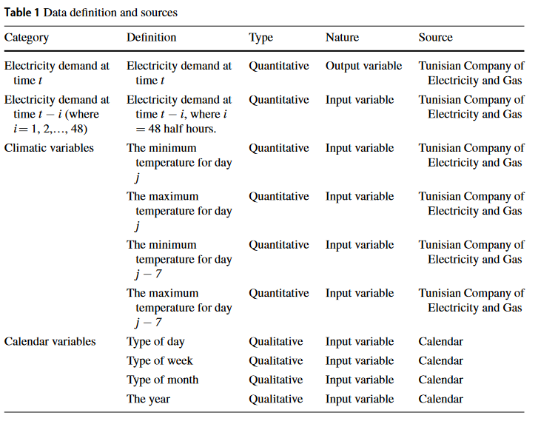

Title:  A review on applications of ANN and SVM for building electrical energy consumption forecasting | Year: 2014  ISSN: 1364-0321  zetero: yes  saved:
Abstract
The rapid development of human population, buildings and technology application currently has caused electric consumption to grow rapidly. Therefore, efficient energy management and forecasting energy consumption for buildings are important in decision-making for effective energy saving and development in particular places. This paper reviews the building electrical energy forecasting method using artificial intelligence (AI) methods such as support vector machine (SVM) and artificial neural networks (ANN). Both methods are widely used in the field of forecasting and their aim on finding the most accurate approach is ever continuing. Besides the already existing single method of forecasting, the hybridization of the two forecasting methods has the potential to be applied for more accurate results. Further research works are currently ongoing, regarding the potential of hybrid method of Group Method of Data Handling (GMDH) and Least Square Support Vector Machine (LSSVM), or known as GLSSVM, to forecast building electrical energy consumption.
Notes
- Identified that geographical and location of a building influences electric energy consumption
- Factors weather condition, surrounding temperature where the country is located, as well as seasons
- Says air conditioning consumes the most of electrical energy
- 3 categories of forecasting
  - Engineering method
  - Statistical method
  - AI method
- hybrid Genetic Algorithm-Adaptive Network-based Fuzzy Inference System (GA-ANFIS) outperformed a ANN

Title:  Boosted neural networks for improved short-term electric load forecasting | Year: 2016  ISSN: 0378-7796  zetero: yes  saved:
Abstract
Boosted neural networks (BNNs) lower load forecasting error and its variation.•The BNNs consist of iteratively training different neural network models.•The BNNs need lower computation time compared to bagged neural networks.•Data from the New England Pool region show the improvement offered by the BNNs. This paper presents an improved technique for short-term electric load forecasting making use of boosted neural networks (BooNN). The BooNN consist of combining a set of artificial neural networks (ANNs) trained iteratively. At each iteration, the error between the estimated output from the ANN model trained in the previous iteration and the target output is minimized. The final predicted result is the weighted sum of output from all the trained models. This process reduces the magnitude of forecasting errors and their variation compared to a single ANN and bagged neural networks (BNN). It further significantly lowers computational time compared to BNN. Results with real data further confirm that BooNN lead to improved load forecasting performance with respect to other existing techniques.
Notes
- Since the economy and reliability of operations of a power system are greatly affected by electric load, cost savings mainly depend on load forecasting accuracy. The load dispatcher at the main dispatch center is responsible for maintaining and controlling the flow of electricity through purchase, sale and scheduling of electricity. The dispatcher is required to have an estimate of the load pattern in advance so that sufficient generation can be allocated to meet the customers’ requirements. Overestimating future load can cause starting of unnecessary generating units that will lead to increased reserve and operating costs. Underestimating future load will lead to a failure for providing operating reserve and stability to the system, which can cause a breakdown of the power system network

Title:  Machine-Learning based methods in short-term load forecasting | Year: 2021  ISSN: 1040-6190  zetero: yes  saved:
Abstract
Short-term load forecasting is of great significance to the secure and efficient operation of power systems. However, loads can be affected by a variety of external impact factors and thus involve high levels of uncertainties. So it is a challenging task to achieve an accurate load forecast. This paper discusses three commonly-used machine-learning methods used for load forecasting, i.e., the support vector machine method, the random forest regression method, and the long short-term memory neural network method. The features and applications of these methods are analysed and compared. By integrating the advantages of these methods, a fusion forecasting approach and a data preprocessing technique are proposed for improving the forecasting accuracy. A comparative study based on real load data is performed to verify that the proposed approach is capable of achieving a relatively higher forecasting accuracy.
Notes
- Incorporation of renewable energy is growing in power systems which is identified as a challenge to power system scheduling and dispatch
- Past research
  - Traditional methods – time series analysis and regression analysis
    - Low accuracy, weak capability of integrating impact factors such as weather data. And low sensitivity concerning inpujt data
  - Recently machine learning technologies introduced into STLF
    - ANN SVM RF and LSTM
    - Chen originally applied SVM method and now a range of others have proposed other SVM to achieve more accurate results
      - (Jiang et al., 2017; Hou et al., 2018; Chen et al., 2017; Barman et al., 2018; Lu et al., 2019; Chen et al., 2019; Hoori et al., 2020).
    - RF algorithms
- Jiang proposed a support vector regression (SVR)-based predictor and a hybrid parameter optimization based forecasting method to provide a high-precision and high-resolution STLF (Jiang et al., 2017)
- Barman proposed a regional hybrid short-term load forecasting model by considering regional climate conditions and using SVR model and grasshopper optimization algorithm (Barman et al., 2018). The results show that the proposed model has better accuracy than the traditional STLF model which uses temperature as the only climate factor.
- The RF integrating multiple decision trees to form a classifier which has the advantages of strong generalization ability, fewer parameters and high prediction accuracy (Wu et al., 2015; Lahouar and Ben, 2015; Jurado et al., 2015; Uriarte et al., 2016; Li et al., 2019).
- Wu improved the RF method by using gray projection to propose a splitting algorithm (Wuet al., 2015); the experimental results showed that the proposed one has higher prediction accuracy and robustness than the original algorithms
- Long short term memory models also purposed to load forecasting problems . Kong achieved higher accuracy than benchmarks when testing on publicly available residential smart-meter data (Kong et al.,2019). It showed

- Paper goes over SVM, RF and LSTM and compares advantages and disadvantages when using to solve STLF problem, and suggests a single model may not achieve a satisfying accuracy level in STLF while proposing a fusion approach together with data pre-processing method.

- Data preprocessing methods:
- Divide abnormal data into categories
  - bad data (caused by failure of meters)
  - distorted data (refers to sudden drop of load typically from change of large industrial load in the grid)
    - detecting distorted data using data horizontal comparison method & time-window mean-standard-deviation comparison method (latter is suggested to be have more pros than cons VS the former)
- Some people use AI in data preprocessing:
- Self-organizing map (SOM) NN (Diaz et al., 2019)
- the empirical mode decomposition (EMD) (Huanget al., 1999)
- the ensemble empirical mode decomposition (EEMD) (Hong et al., 2012)
- variational mode decomposition (VMD) (Aliet al., 2018)
- set pair analysis, and the isolation forest method
- This paper uses EEMD method

Points to include in Lit
Preprocessing data
Machine learning techniques have also been incorporated into data preprocessing with positive results. (This paper above) outlines a few ways namely, self-organizing maps by (someone et al), variational mode decomposition by (someone et al) and empirical mode decomposition (EMD) by (someone else et al). They recommend using a variation of the EMD called EEMD that covers some shortcomings of EMD. Abnormal data is distinguished into two categories: bad data, caused by failure in devices (such as meter readers) and distorted data, typical of sudden load changes due to a specific industrial action.
(the paper above) also confers that hybrid models produce more accurate and robust models. They incorporate SVM, RF and LSTM models into a fusion frame before outputting the optimal result.

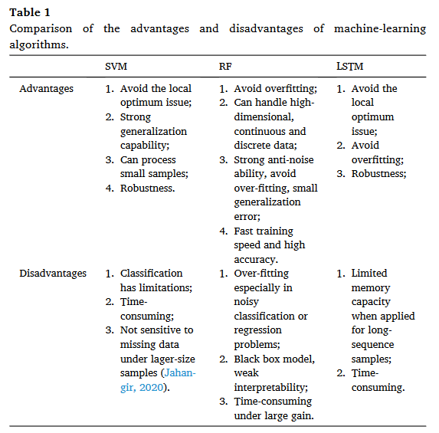
Title:  Neural networks in forecasting electrical energy consumption: univariate and multivariate approaches | Year: 2002  ISSN: 0363-907X  zetero: yes  saved:
Abstract
This paper presents an artificial neural network (ANN) approach to electric energy consumption (EEC) forecasting in Lebanon. In order to provide the forecasted energy consumption, the ANN interpolates among the EEC and its determinants in a training data set. In this study, four ANN models are presented and implemented on real EEC data. The first model is a univariate model based on past consumption values. The second model is a multivariate model based on EEC time series and a weather‐dependent variable, namely, degree days (DD). The third model is also a multivariate model based on EEC and a gross domestic product (GDP) proxy, namely, total imports (TI). Finally, the fourth model combines EEC, DD and TI. Forecasting performance measures such as mean square errors (MSE), mean absolute deviations (MAD), mean percentage square errors (MPSE) and mean absolute percentage errors (MAPE) are presented for all models. Copyright © 2002 John Wiley & Sons, Ltd.
Notes

Title:  Short Term Electric Load Forecasting Based on Data  Transformation and Statistical Machine Learning | Year: 2021  ISSN: 2076-3417  zetero: yes  saved:
Abstract
The continuous penetration of renewable energy resources (RES) into the energy mix and the transition of the traditional electric grid towards a more intelligent, flexible and interactive system, has brought electrical load forecasting to the foreground of smart grid planning and operation. Predicting the electric load is a challenging task due to its high volatility and uncertainty, either when it refers to the distribution system or to a single household. In this paper, a novel methodology is introduced which leverages the advantages of the state-of-the-art deep learning algorithms and specifically the Convolution Neural Nets (CNN). The main feature of the proposed methodology is the exploitation of the statistical properties of each time series dataset, so as to optimize the hyper-parameters of the neural network and in addition transform the given dataset into a form that allows maximum exploitation of the CNN algorithm's advantages. The proposed algorithm is compared with the LSTM (Long Short Term Memory) technique which is the state of the art solution for electric load forecasting. The evaluation of the algorithms was conducted by employing three open-source, publicly available datasets. The experimental results show strong evidence of the effectiveness of the proposed methodology.
Notes
- Paper focus on deep-learning convolution neural nets CNN (deep learning ANNs) and the data preprocessing techniques used
- The most successful and popular algorithm is long short term memory LSTM [7] => Recurrent Neural Network uses long and short term relationships in the data series to build a predictive model
- Papers focus is the preprocessing steps => data transformations based on data features (ie stationarity)
- Paper suggests that CNN despite mostly used for image processing related tasks can be applied to STLF
- Paper goes over an approach for model and model parameter selection tuning resulting in lower forecasting errors compared to LSTM model. They note the data transform performed using statistical analysis allows for optimal input selection for models
  - The most common input was the previous state (t-1) forecasted variable
- Introduce term very short-term load forecasting (VSTLF) 5min forecasting horizon
- Exponential smoothing models and its variations (eg double and triple seasonal exponential smoothing) have shown good results [17] but are less popular because they cannot handle exogenous variables.
- The article distinguishes between high voltage (system level) and low voltage demand (household level). HV uses the aggregated demand of thousands/millions of consumers and is less volatile than the LV demand.
- Recent methods upon load forecasting can be found in [25].
- Introduced term “double peak” error for spiky data
- Another challenge to forecasting is the demand response programs, since some customers are willing to alter consumption according to price signals while others are not. => authors detected price driven customers by applying non parametric test so they can forecast the groups separately
- Papers show the strong correlation between weather effects and demand. Authors discovered the temperature humidity index (THI) may NOT be optimal for load forecasting models. Instead

- methods of determining the inputs of NN for STLF still remains an open question.
- Paper used autocorrelation coefficients of the given datasets by applying the Auto-correlation function (ACF) test
- Paper says the input for the NN are determined after examining the ACF

Title:  Data driven machine learning models for short‐term load forecasting considering electrical vehicle load | Year: 2019  ISSN 2578-4862  zetero: yes  saved:
Abstract
Electric vehicles (EVs) are gaining popularity due to their fuel efficiency and ability to reduce greenhouse gas emissions. Significant penetration of EVs with unregulated charging, which can have a substantial impact on power networks. Accurate load predictions, including the charging of EVs are crucial for ensuring the cost‐effective and dependable operation of power systems. In order to estimate short‐term load in the presence of EV load, the XG (extreme gradient) boost algorithm is proposed and the effectiveness of the performances are checked against other models. A variety of distinct meteorological parameters and the electrical load pattern for the years 2017 and 2018 for Northeast India are used to train the machine learning classifier models. R ‐squared value analyses are also performed to identify the most correlated input parameters that influence the results of various models. Analysis shows that temperature, cloud cover, heat index, dew point, wind chill, and perceived temperature are substantially connected with electricity consumption. The performance of XG boost is outperformed by comparing prediction results with decision tree, random forest, K nearest neighbors, and logistic regression. Three separate case studies were employed for verification using the precision, F1 score, sensitivity, specificity, and accuracy metrics. Our findings demonstrate that, in comparison to other forecasting models, XG Boost exhibits higher accuracy (83.84%, 81.51%, and 85.97%) and robust forecasts.
Notes
- A good study that compares multiple ML methods and models on single data set, the study uses confusion matrix and F1 scores to compare each model
- Analysis shows that temperature, cloud cover, heat index, dew point, wind chill, and perceived temperature are substantially connected with electricity consumption.
- The performance of XG boost is outperformed by comparing prediction results with decision tree, random forest, K nearest neighbors, and logistic regression.
- Three separate case studies were employed for verification using the precision, F1 score, sensitivity, specificity, and accuracy metrics. Our findings demonstrate that, in comparison to other forecasting models, XG Boost exhibits higher accuracy (83.84%, 81.51%, and 85.97%) and robust forecasts.
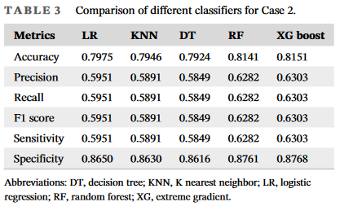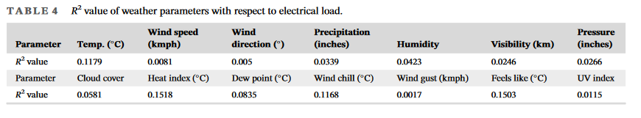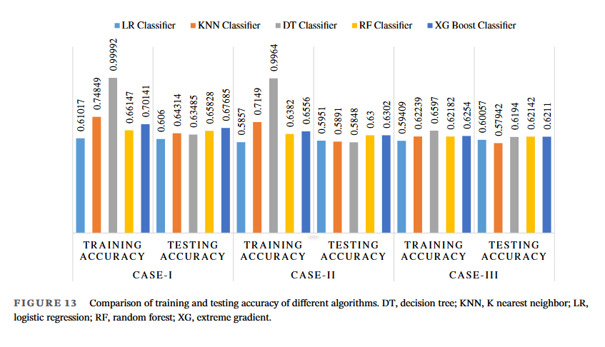

Final Report - Sources
Title:  Exploratory Data Analysis Based Short-Term Electrical Load Forecasting: A Comprehensive Analysis | Year: 2021  DOI: 10.3390/en14175510  zetero: yes  saved:
Abstract
Power system planning in numerous electric utilities merely relies on the conventional statistical methodologies, such as ARIMA for short-term electrical load forecasting, which is incapable of determining the non-linearities induced by the non-linear seasonal data, which affect the electrical load. This research work presents a comprehensive overview of modern linear and non-linear parametric modeling techniques for short-term electrical load forecasting to ensure stable and reliable power system operations by mitigating non-linearities in electrical load data. Based on the findings of exploratory data analysis, the temporal and climatic factors are identified as the potential input features in these modeling techniques. The real-time electrical load and meteorological data of the city of Lahore in Pakistan are considered to analyze the reliability of different state-of-the-art linear and non-linear parametric methodologies. Based on performance indices, such as Root Mean Square Error (RMSE), Mean Absolute Percentage Error (MAPE) and Mean Absolute Error (MAE), the qualitative and quantitative comparisons have been conferred among these scientific rationales. The experimental results reveal that the ANN-LM with a single hidden layer performs relatively better in terms of performance indices compared to OE, ARX, ARMAX, SVM, ANN-PSO, KNN, ANN-LM with two hidden layers and bootstrap aggregation models.
Notes
- STLF also assists in economical fuel scheduling, automatic generation control, economic dispatch, voltage stability of HVAC and HVDC lines, and avoiding highly disruptive blackouts [7]
- state-of-the-art linear and non-linear parametric methodologies
- After modelling they used evaluations such as Mean Absolute Percentage Error (MAPE), Root mean square error (RMSE), mean absolute error (MAE) and R-squared value and standard deviation
- Found ANN LM (Levenberg-marquardt) algorithm with one hidden layer performed well
- Expanatory Analysis included:
  - Auto correlation analysis
  - Quantile-quantil analysis
  - Box-plot analysis
- Study compares traditional time-series stat models, linear and non-linear parametric methodologies.
- Section 2: lit review, SECTION 3: exploratory data analysis, SEC4 various models and experimental results SEC6: conclusion and future direction
- SECTION2: Lit review
  - Uses lagged average values to convert non-staionary data into stationary ones.
  - Seasonality observed using Autocorrelation ACF and partial auto-correlation PACF analysis
  - “the statistical regression algorithms are inadequate in capturing the temporal variations and non-linear electrical load patterns”
  - To overcome shortcommings PCA, sensitivity analysis and step-wise regression can be done to improve statistical regression models. SVD should be used over PCA since SVD is proficient in extracting both seasonal and random components (more robust) than PCA, however it is more computationally expensive
  - KNN (k nearest neighbor) is also proposed ML algorithm that can deal with non-linear temporal variations. They have proved to be imperfect while forecasting load due to insufficient hyperparameters which also result in overfitting. KNN prone to the curse of dimensionality in high dimension datasets
- SECTION 3: Exploratory Data Analysis
  - 3.1- Provide a good summary of the dataset (might be good template for our dataset description)
  - 3.2 Input parameters
    - Auto correlation analysis – the degree of resemblance between a given time-series and a lagged version of itself over consecutive time intervals
    - Electrical load data is normalized between 0-1, the strong correlation in the plots suggests that load has strong correlation with previous lagged load values
    - quantile-Quantile plots (QQplot) : does there exist a relationship between load and climate data. Qqplot of the load that are plotted against its lagged values for month January
    - Boxplots –
- SECTION 4: Methodology
  - Models
    - ARX-AR with exogenous inputs
    - ARMAX -ARMA model with exogenous inputs incorporated
    - Output error model
    - SVM
    - K-Nearest Neighbour KNN
    - Bootstrap Aggregation – Bagged Trees: Ensemble ML algorithm which bags ensemble trees for regression or classification, reducing variance of forecasting model without increasing bias. Trees are grown from bootstrap replica of input data, subsets of data are created from training samples which are selected randomly with substitution. Predictions are obtained by averaging outcomes from all decision trees.
    - ANN
- SECTION 5 – Experimental Results
  - Pg 13/22

Title:  AEMO doc  Forecasting Approach_Electricity Demand Forecasting Methodology_final | Year: 2023  DOI:  zetero:  saved:
Abstract

Notes
AEMO uses a monthly regression model based on five years (60 months) of historical data [21/83]

Title:  Electric load forecasting based on deep learning and optimized by heuristic algorithm in smart grid | Year:2020  ISBN:  DOI: 10.1016/j.apenergy.2020.114915  zetero: NO  saved:
Abstract
•A novel hybrid electric load forecasting model based on MMI-FCRBM-GWDO is developed for the decision making of a smart grid.•To overcome the problem of curse of dimensionality a novel MMI technique is proposed for feature selection.•The forecast accuracy and convergence rate of FCRBM is enhanced by GWDO.•The proposed model is tested on hourly load data of USA power grids: FE, Dayton, and EKPC. Accurate electric load forecasting is important due to its application in the decision making and operation of the power grid. However, the electric load profile is a complex signal due to the non-linear and stochastic behavior of consumers. Despite much research conducted in this area; still, accurate forecasting models are needed. In this article, a novel hybrid short-term electric load forecasting model is proposed. The proposed model is an integrated framework of data pre-processing and feature selection module, training and forecasting module, and an optimization module. The data pre-processing and feature selection module is based on modified mutual information (MMI) technique, which is an improved version of the mutual information technique, used to select abstractive features from historical data. The training and forecasting module is based on factored conditional restricted Boltzmann machine (FCRBM), which is a deep learning model, empowered via learning to forecast the future electric load. The optimization module is based on our proposed genetic wind-driven (GWDO) optimization algorithm, which is used to fine-tune the adjustable parameters of the model. The accuracy of the proposed framework is evaluated through historical hourly load data of three USA power grids, taken from publicly available PJM electricity market. The proposed model is validated by comparing it with four recent forecasting models like Bi-level, mutual information-based artificial neural network (MI-ANN), ANN-based accurate and fast converging (AFC-ANN), and long short-term memory (LSTM) in terms of accuracy and convergence rate.
Notes
- Nomenclature section that outlined all their abbreviations
- deep learning methods such as RBM and conditional RBM (CRBM) have better performance at the large datasets, the models have deep layers which can capture highly abstracted features
  - the models provided high quality forecasting
  - used relu activation for faster convergence and also overcomes the problem of vanishing gradient
- created a 3d heatmap for month vs years vs load
- section (4.2) Learning Curves – compare the performance of models on training and testing data samples across a varying number of epochs. Learning curve enables verification whether the chosen model is learning or memorizing the data ie high variance and bias
  - overfitting when test error at a certain point starts to increase and training error decreases → model is memorizing but not learning leading to bad generalisations
    - avoided the overfitting using the dropout method and early stopping
- hourly resolution models
- so they introduced concept of learning vs memorization if model learns it has good generalisation (low bias and variance) otherwise its just memorizing.
- Introduce scalability analysis if proposed model is suitable to scale for said situations
- Graphed the CDF cumulative distribution function of error for the different datasets across the different models
- Conclusion
  - With accurate electric load forecasting, operators are capable to develop an optimal market plan to enhance the economic benefits of energy management. Therefore, it is a significant goal for scholars and industry to develop a forecasting model, which provides robust, stable, and accurate load forecasting
  - Hybrid models fully utilize the advantages of individual models and have improved performances
  - They improved results with the techniques
    - selecting desired features from data-driven
    - train adapted model to forecast day and week ahead electric load with hour resolutions
    - GWDO algorithm used to fine tune hyper parameters
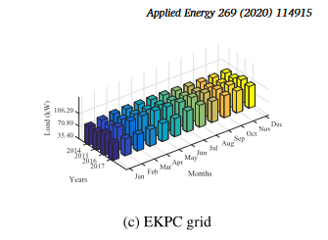

PROS AND CONS of DIFFERENT ML MODELS

Title:  A Comparative Analysis of Machine Learning Methods for Short-Term Load Forecasting Systems  Access https://www.mdpi.com/2071-1050/12/9/3612 | Year: 2020  ISBN:  DOI:  zetero: yes  saved:
Abstract
Estimating the electricity load is a crucial task in the planning of power generation systems and the efficient operation and sustainable growth of modern electricity supply networks. Especially with the advent of smart grids, the need for fairly precise and highly reliable estimation of electricity load is greater than ever. It is a challenging task to estimate the electricity load with high precision. Many energy demand management methods are used to estimate future energy demands correctly. Machine learning methods are well adapted to the nature of the electrical load, as they can model complicated nonlinear connections through a learning process containing historical data patterns. Many scientists have used machine learning (ML) to anticipate failure before it occurs as well as predict the outcome. ML is an artificial intelligence (AI) subdomain that involves studying and developing mathematical algorithms to understand data or obtain data directly without relying on a prearranged model algorithm. ML is applied in all industries. In this paper, machine learning strategies including artificial neural network (ANN), multiple linear regression (MLR), adaptive neuro-fuzzy inference system (ANFIS), and support vector machine (SVM) were used to estimate electricity demand and propose criteria for power generation in Cyprus. The simulations were adapted to real historical data explaining the electricity usage in 2016 and 2107 with long-term and short-term analysis. It was observed that electricity load is a result of temperature, humidity, solar irradiation, population, gross national income (GNI) per capita, and the electricity price per kilowatt-hour, which provide input parameters for the ML algorithms. Using electricity load data from Cyprus, the performance of the ML algorithms was thoroughly evaluated. The results of long-term and short-term studies show that SVM and ANN are comparatively superior to other ML methods, providing more reliable and precise outcomes in terms of fewer estimation errors for Cyprus’s time series forecasting criteria for power generation.
Notes
- global energy demand grows exponentially
- accurate forecasting good for sustainable economic prosperity and environmental security
- demand management has to consider series of technical, organizational or behavioral solutions to decrease demand
- energy demand linked to price of energy, GDP and population
- predicting power demand is difficult as electricity time series is complex, with nonlinear dependencies and contains both periodic and random components. The periodic components are due to nested intervals on weekly and daily basis, while the random components due to inherent fluctuations in household electricity usage, changes in industry usage and variations due to weather changes, special events, calendar and economic factors, and malfunction of measuring devices.
- Forecasting important for maintenance and planning of electric power systematic
- approaches to forecasting divided into ML and statistic based approaches and models used are divided into gray box, white box and black box.
- Different models seen include
  - The AI approaches include ANN, SVM, genetic models and fuzzy logic // support vector regression
  - statistical approaches – kalman filters, multiple regression approaches and AIRMA
- the nature of electricity load is well suited to machine learning algorithms (can model complex nonlinear relationships)
- For this papers model building they used, time, temperature, humidity, solar irradiation, population GNI per capita, and electricity price per kWh
- Factors affecting electrical load

Comparison of Machine Learning Techniques for Short-Term Electricity Load Forecasting

Title:  Optimizing Building Short-Term Load Forecasting: A Comparative Analysis of Machine Learning Models | Year:2024  ISBN:  DOI: 10.3390/en17061450  zetero: yes  saved:
Abstract
The building sector, known for its high energy consumption, needs to reduce its energy use due to rising greenhouse gas emissions. To attain this goal, a projection for domestic energy usage is needed. This work optimizes short-term load forecasting (STLF) in the building sector while considering several variables (energy consumption/generation, weather information, etc.) that impact energy use. It performs a comparative analysis of various machine learning (ML) models based on different data resolutions and time steps ahead (15 min, 30 min, and 1 h with 4-step-, 2-step-, and 1-step-ahead, respectively) to identify the most accurate prediction method. Performance assessment showed that models like histogram gradient-boosting regression (HGBR), light gradient-boosting machine regression (LGBMR), extra trees regression (ETR), ridge regression (RR), Bayesian ridge regression (BRR), and categorical boosting regression (CBR) outperformed others, each for a specific resolution. Model performance was reported using R2, root mean square error (RMSE), coefficient of variation of RMSE (CVRMSE), normalized RMSE (NRMSE), mean absolute error (MAE), and execution time. The best overall model performance indicated that the resampled 1 h 1-step-ahead prediction was more accurate than the 15 min 4-step-ahead and the 30 min 2-step-ahead predictions. Findings reveal that data preparation is vital for the accuracy of prediction models and should be model-adjusted.
Notes
The study mostly focuses on building (room #’s, types of appliances used ect) however identifies weather (temp and relative humidity) and the use of lagged variables as part of the methodology. It identifies that lower performance of time series predictions that arise with changing weather conditions is a challange
- data preparation is vital for the accuracy of prediction models and should be model-adjusted.
- Load forecasting has transistioned over the years and has become a pillar for energy planning and operation – however little attention to LF for buildings
- study explores effect of different time resolutions and forecasting time steps by resampling the data into 30m and 1hr time steps, the models where comparedto their 1h ahead predictions using 1,2 and 4 steps for each resolution
- A good overview of modelling approaches
  - time series modeling and prediction are approached with linear or nonlinear forecasting eg:ARMA. There has been numerious studies on the application of AI to solve forecasting problems using nonlinear time series [31-33] MLP, SVM (radia kernel), RF and GBM
  - like most studdies used RMSE, MAPE, MAE
- STLF is intended to estimate electrical demand for 30 min up to two weeks [ 37 ] and is applied to the day-ahead load, energy network planning, and maintenance. STLF can improve operational safety and reduce power system costs
- For the STLF task for buildings of the several deep learning techniques used to forecsat energy consumption LSTM/gated recurrent unit (GRU) model performed the best [47]

A study created and validated sixteen architectures based on long short-term memory (LSTM) with attention, convolution, and bidirectional processing processes. The findings demonstrated that recursive prediction significantly lowers model accuracy. This effect was more noticeable in the model that predicts temperature and humidity.
- Section 2.5 challenges in household energy forecasting
- 3. Methodology
  - data preprocessing: analyse the dataset using robust techniuqes due to missing values and outliers, data preprocessing quality directly affects model performance.
  - Handling missing values – linear interpolation which is commonly used for time series data to fill missing values with the preceding or succeeding ones.
  - Outliers – aka anomalies are typical data points that deviate signif from expected values
    - pose a risk to ML algorithms as they can disrupt patterns and rules that the algorithm learn
    - to address assessed the deviation of median values from the mean as well as differences between 25th and 75th percentiles
    - for energy deman outliers they sorting frequency of unique values in ascending and descending order detects outliers in energy consumption data
    - for temp data replaced outliers with 99th percentile of the data values
  - performance of ML affected by scale of numeric values, also helps with convergence, they used standardscaler from scikit-learn (they said this method was preferred because the data observations have a very small deviation from the mean values)
- Feature extraction/engineering
  - feature extraction to reduce dimensionality – research demonstrated that integrating time-related data improves the performance of electricity forecasting algorithms [65]
- 3.3 Exploratory Data Analysis – visualizing observable trends in 1h resolution can enhance comprehension of the data-driven
  - comparing winter and summer months for heating demands
  - 3.3.1 weather data relationships
    - scatterplot energy vs weather variables
- 3.3.2 autocorrelation analyis
  - consider the correlation between the observations specified by the lag to determine persistent relations in the data-driven
  - can help determine if data is stationary
    - unaltered pattern in the mean fluctuation and autocorrelation over time-related
    - to establish model order must consider the lag values in the blue area which is the 95% CI and serves as the indicator for significance.
- 3.4 Algorithmic modeling
- 3.4.3 Model Selection and training
  - depends on data avaliability
  - dataset divided horizontally into train/test .8/.2
  - Having features that don’t correlate to the response impacts models performance and increases computation time
  - they used grid search with CV from scikit-library, further they used the SW (sliding window) technique for all 3 resoultions (15m, 30m, 1hr)
- 3.5 Performance measures
  - statistical metrics, common used for time series are RMSE, MAE, R_squared, CVRMSE, NRMSE all quantify the variability of observations around the mean

Title:  Saved: | Year:  ISBN:  DOI:  APA 7 (Reference):  APA 7 (Citation):
Abstract

Notes

Title:  An Ensemble Model Based on Machine Learning Methods and Data Preprocessing for Short-Term Electric Load Forecasting | Year: 2017  ISSN: 1996-1073  EISSN: 1996-1073  DOI: 10.3390/en10081186  Zotero: yes  Saved: yes
Abstract
The experience with deregulated electricity market has shown the increasingly important role of short-term electric load forecasting in the energy producing and scheduling. However, because of nonlinear, stochastic and nonstable characteristics associated with the electric load series, it is extremely difficult to precisely forecast the electric load. This paper aims to establish a novel ensemble model based on variational mode decomposition (VMD) and extreme learning machine (ELM) optimized by differential evolution (DE) algorithm for multi-step ahead electric load forecasting. The proposed model is novel in the sense that VMD is firstly applied to decompose the original electric load series into a set of components with different frequencies in order to effectively eliminate the stochastic fluctuation characteristic so as to improve the overall prediction accuracy. The proposed ensemble model is tested using two electric load series collected from New South Wales (NSW) and Queensland (QLD) in the Australian electricity market. The experimental results show that: (1) the data preprocessing by VMD can effectively decrease the stochastic fluctuation characteristics that existed in the electric load series, consequently improving the whole forecasting accuracy, and; (2) the proposed forecasting model performs better than all other benchmark models for both one-step and multi-step ahead electric load forecasting.
Notes
With the fast development of machine learning method, many of them have been widely used in
various forecasting issues, such as artiﬁcial neural network (ANN), extreme learning machine (ELM)
and support vector machine (SVM). Yolcu et al. [12] developed a new ANN model based on both
linear and nonlinear structures for time series predicting. Gutierrez-Corea et al. [13 ] focused on the
usage of ANN in short-term global solar irradiance forecasting. Li et al. [14 ] proposed a novel model
based on modiﬁed artiﬁcial bee colony (MABC) and ELM for short-term electric load forecasting, and
the experimental results showed that the proposed hybrid model owned the best forecasting ability
with comparison to the other benchmark models adopted in their paper. Zhou et al. [ 15] developed a
hybrid model based on SVM for short-term wind speed forecasting. Chen and Lee [ 16 ] established
a weighted least square support vector machine (LSSVM) model based on learning system for time
series forecasting, and the experimental results demonstrated the effectiveness of the proposed model.

Even though the hybrid model performs better than the single forecasting model,
they still cannot effectively deal with the nonlinear and nonstationary characteristics associated with
majority of time series in practical life. Therefore, many researchers have integrated various data
preprocessing techniques into the forecasting models in order to effectively decrease the forecasting
errors. Such as empirical mode decomposition (EMD) and ensemble EMD (EEMD), wavelet packet transform (WPT) and variational mode decomposition (VMD)

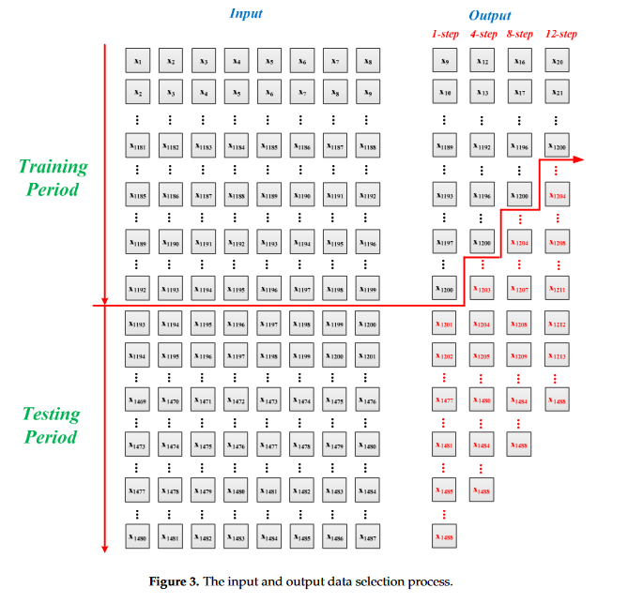

"Electricity Load Forecasting: Literature Survey and Classification of Methods" by S. Makridakis and D. Wheelwright:

Title: (Provided by Sonnit)  Data driven prediction models of energy use of appliances in a low-energy house | Year: 2017  ISSN: 0378-7788  DOI: 10.1016/j.enbuild.2017.01.083  zetero: yes
Description
The appliances energy consumption prediction in a low energy house has been studied.•Weather data from a nearby station was found to improve the prediction.•Pressure, air temperature and wind speed are important parameters in the prediction.•Data from a WSN that measures temperature and humidity increase the pred. accuracy.•From the WSN, the kitchen, laundry and living room data ranked high in importance. This paper presents and discusses data-driven predictive models for the energy use of appliances. Data used include measurements of temperature and humidity sensors from a wireless network, weather from a nearby airport station and recorded energy use of lighting fixtures. The paper discusses data filtering to remove non-predictive parameters and feature ranking. Four statistical models were trained with repeated cross validation and evaluated in a testing set: (a) multiple linear regression, (b) support vector machine with radial kernel, (c) random forest and (d) gradient boosting machines (GBM). The best model (GBM) was able to explain 97% of the variance (R2) in the training set and with 57% in the testing set when using all the predictors. From the wireless network, the data from the kitchen, laundry and living room were ranked the highest in importance for the energy prediction. The prediction models with only the weather data, selected the atmospheric pressure (which is correlated to wind speed) as the most relevant weather data variable in the prediction. Therefore, atmospheric pressure may be important to include in energy prediction models and for building performance modeling.

Abstract
This paper presents and discusses data-driven predictive models for the energy use of appliances. Data used include measurements oftemperature and humidity sensors from a wireless network, weather from a nearby airport station and recorded energy use of lighting fixtures. The paper discusses data filtering to remove non-predictive parameters and feature ranking. Four statistical models were trained with repeated cross validation and evaluated in a testing set: (a) multiple linear regression, (b) support vector machine with radial kernel, (c) random forest and (d) gradient boosting machines (GBM). The best model (GBM) was able to explain 97% of the variance (R2) in the training set and with 57% in the testing set when using all the predictors. From the wireless network, the data from the kitchen, laundry and living room were ranked the highest in importance for the energy prediction. The prediction models with only the weather data, selected the atmospheric pressure (which is correlated to wind speed) as the most relevant weather data variable in the prediction. Therefore, atmospheric pressure may be important to include in energy prediction models and for building performance modeling.
Notes
- 20-30% of household demand is is due to appliances
- compared inside and outside household temperatures
- four regression models tested
  - MLM
  - SVM
  - RF
  - GBM
- another study generated data using markov chain monte carlo technique to generate synthetic data and is recommended by the author to estimate energy demand of applicances, lighting and heating.
- They study goes over a review of papers that deal with electricity load predictions
  - studies used methods such as Multiple regression, NN, SVM and time seriestechniques. Models consider time of day, outdoor temp, month, weekend, holidays, yesterdays consumption, rainfall index, global solar radiation, wind speed and occupancy
  - Another study used HDD/CDD, GDP and humidity when available to explain variability of monthly demand 91-95%
  - Another used explicit duration hidden markov model to detect loads
- A complete data set is often necessary for statistical regression models to work.
- Some other variables the main study considered number of seconds from midnight, the week status (weekend or workday) and the day of the week.
- EDA for their study
  - 75/25% train/test splits
  - created pair plots to show relationship between all variables with response (energy consumption) for only the training set.
  - Hourly heat map created for four consecutive weeks of data (look this up)
  - They used Boruta package for feature selection → importance of attributes with importance of shadow attributes that are created by shuffling original ones
  - To test how many variables are optimal to minimize the RMSE the recursive feature elimination RFE is used to select the optimal inputs. The RFE algorithm uses random forestsregression method and was trained with 10 cv sets
- Model performance (section 3.3)
  - all regression models trained with 10 fold CV
  - used parallel computations to speed up training
  - SVM with radial kernel -
  - grid search for hyperparameters
  - random forest made of several regression trees built with a random sample of selected predictors, the idea is to decorrelate the trees and imporve the prediction. RF requires finding optimum #trees and the #randomly selected predictors
  - after training the models each model has 30 restults from 10 cv sets and 3 repeats this info was used to plot rmse for each model together with CI and R-squared value the best models are the ones that provide the lowest rmse and highest R2 value
- Evaluating the prediction with different data subsets:
  - after they found the best model (GBM model) that provided best RMSE and R2 they used it to study prediction performance with different subsets of predictors.
- Discussion of results (section 3.5)
  - printed grid search comparing cost with different hyper parameter values
  - printed pair plots of all features vs predictor
  - plotted feature importance for different data subset models

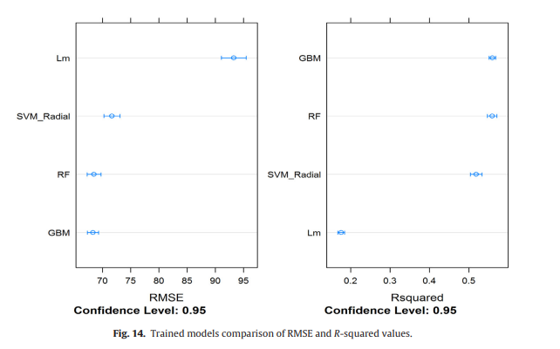

Title:  A decomposition‐based multi‐time dimension long short‐term memory model for short‐term electric load forecasting | Year:2021  ISSN: 1751-8687  EISSN: 1751-8695  DOI: 10.1049/gtd2.12265  zetero:Yes  Saved:
Abstract
Short‐term load forecasting is essential to power systems management. However, most existing forecasting methods fail to fully consider how to rationally integrate the intrinsic time‐related dimensions of electric load data and the decomposition methods into machine learning models so that their prediction accuracy and robustness still have much room for improvement. To solve this problem, this paper proposes a decomposition‐based multi‐time dimension long short‐term memory (DB‐MTD‐LSTM) model for short‐term electric load forecasting (STELF). In DB‐MTD‐LSTM, empirical mode decomposition with adaptive noise (CEEMDAN) is first introduced to smooth non‐linear non‐stationary electric load data and constrain the modal aliasing or noise of decomposed electric load data in the traditional decomposed method. A joint relevant time dimensions method (JRTDM) is then developed using autocorrelation analysis to rationally extract the temporal characteristics of decomposed data in multiple time dimensions. An improved LSTM called MTD‐LSTM is developed by combining JRTDM with LSTM, which can effectively apply multi‐dimensional time characteristics of the decomposed load to improve the predictive accuracy and robustness. Several datasets from Australia and China are performed to check the predictive performance of DB‐MTD‐LSTM. Experimental results verify that DB‐MTD‐LSTM has better predictive accuracy and satisfactory robustness compared with state‐of‐the‐art and conventional predictive models.
Notes
- Paper explores many of the deep learning methods available:
- However short-term power load data has non-stationary and non-linear characteristics, therefore statistical methods may not be competent in tackling such characteristics information
- RFR is ensemble learning method combines many DT’s and can process HD data features
- [25] integrated iForest and LSTM to obtain significant performance improvement in task of STLF
- study combined ANN and wavelet transforms to improve forecasting by decomposing the load series into more stable steries, clustering based methods is also considered an effective method to reduce the forecsating error.
- Identified missing developments
  - most forecasting methods for STLF do not effectively dig out the relationship of the intrinsic time related dimensions of power load data to enhance prediction accuracy
  - proposed deep learning methods (eg DBN LSTM) create some errors in the results as they only use the single feature input structure.
- The paper suggests a novel ensemble NN called decomposition based multi time dimension long short-trem memory model DB MTD LSTM
- Moved to results:
  - they zscore standardizes electric load
  - used 4 metrics for predictive performance evaluations
    - MAE, MAPE, RMSE,
- Section 3.3 Comparable methods
  - For STLF models they limited iterative number to 200 and used top 75% of data for testing and last
  - they showed that different models have varying levels of accuracy across AUS states, noting that NSW power substation data was among some of the more volatile datasets available. Their DB MTD LSTM however outperformed on all 11 datasets (from 2 separate countries)
- section 3.4.3 model assessment
  - split 0.7/0.2/0.1 train/validate/test splitted aemo data
  - carried out experiments repeating 50 times
  - check the difference between validation-RMSE and test-RMSE to ensure a reliable convergence and stability of the model
- The paper then goes on to describe the effect of CEEMDAN by running the experiment with and without the process → the proposed technology of CEEMDAN and JRTDM can improve performance on bench marking models and tested models
- section 3.6 Parameter selection (really its hyperparameter testing)
  - just repeated experiment 50 times while changing hyperparameter values
- Discussion: The DB MTD JRTDM is robust and a promising performer, they attribute it to CEEMDAN that was introduced to decompose electric load data into mulitple sub-time series which effectively smoothens non-linear non-stationary electric load
  - warn that most existing methods of STLF ignore how to reasonable and effectively combine decomposition methods, machine learning methods and the time correlation of power load data in multiple time dimensions to improve the accuracy and stability
  - provides a general predictive framework for STLF which is suitable for other ML models and decomposed methods
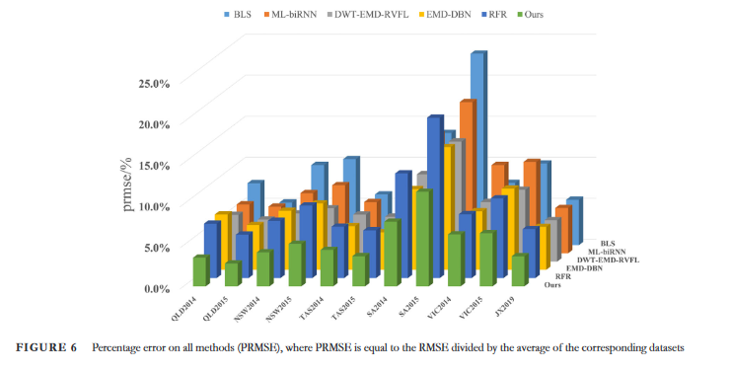

Notes:
facebooks prophet model handles missing data well and it can take data with seasonality and trends
big disadvanatge we cannot add regressors for which we don’t have future values
prophet and ARIMA models fall under uni-variate models with multivariate models, we can model based on features of different time series eg: vector autoregression. Multivariate usually need more data though as you are now predicting multiple time series points

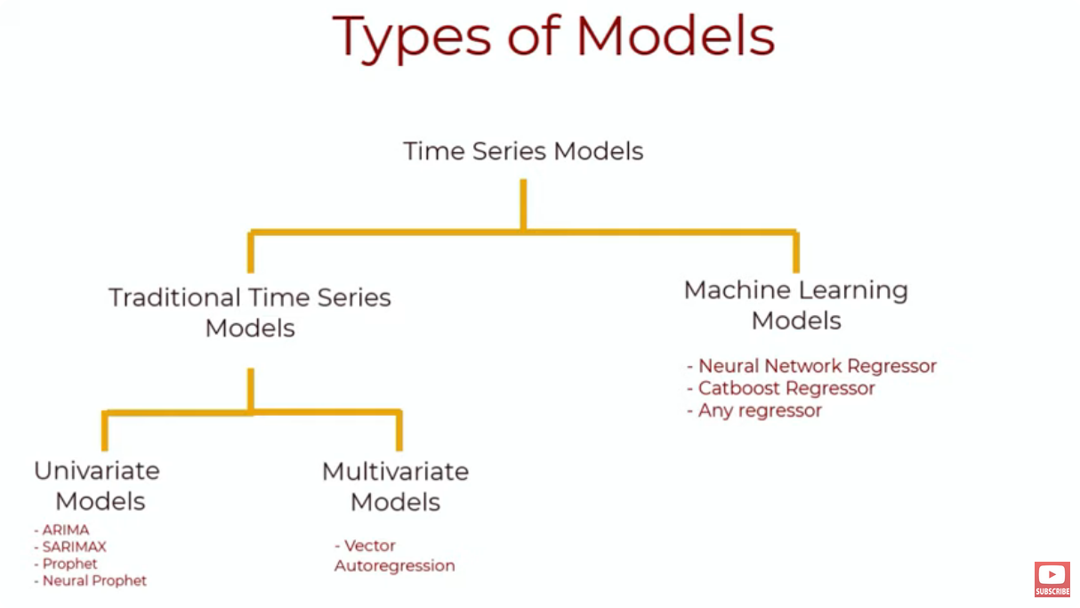
can do arima using the statsmodels library in python

